**Website Project Proposal**

Proposal Requirements: 20 pts. total

1 pt. Project Site Title:

Borden Landscaping Inc.

1 pt. Client:

Borden Landscaping Inc.

2 pts. Goal:

1. Explain what the idea.
2. What will your site do and in what way provides a service or solves a problem.

Our goal for this website is to make a better website for my dad’s landscaping company. By doing this my dad will have an easier access of showing pictures of his previous work to his clients, which he isn’t able to right now. His website currently is very basic and unprofessional.

2pts. Audience

1. Describe the customer base (who your users/audience will be)
2. Describe a visitor using your site (persona, journey map)

1. The customer base for this project would be my dad’s potential clients. By doing having this website, potential clients will be able to see previous projects my dad has completed, and will help his potential clients envision what they want done.

2. The journey map for a customer would see a home page on the website, then see different types of landscaping for example: flower beds, brick paver walkways, fireplaces, etc. By clicking on one of those you will be able to see examples of what you want to see via pictures or even possibly a slideshow.

2 pts.

1. Describe your project road map
2. How far along is the idea development

1. First step for us would be to build a home page and make it look as official as possible, next add buttons to at the top of the homepage with links in them to the other pages. Then make those individual pages with the different things we need. For example, like carousels, forms, and two column pages.

2. The idea development is off to a good start, we think that our balsamiq is in a good spot for us to get going on the coding. We haven’t started the coding yet but got a good idea from my dad on what he wants, and what he wants it to look like.

2 pts. Site Map:

1. Home
2. Design
3. Pictures Page with carousel (page of your choice)
4. Pictures Page with carousel (page of your choice)
5. Pictures Page with tab image gallery
6. Contact Page with form

1 pt. Inspiration Site:

Screenshot of 1 or 2 websites to use as design inspiration - Templated.co for example 1 pt. Color Combination

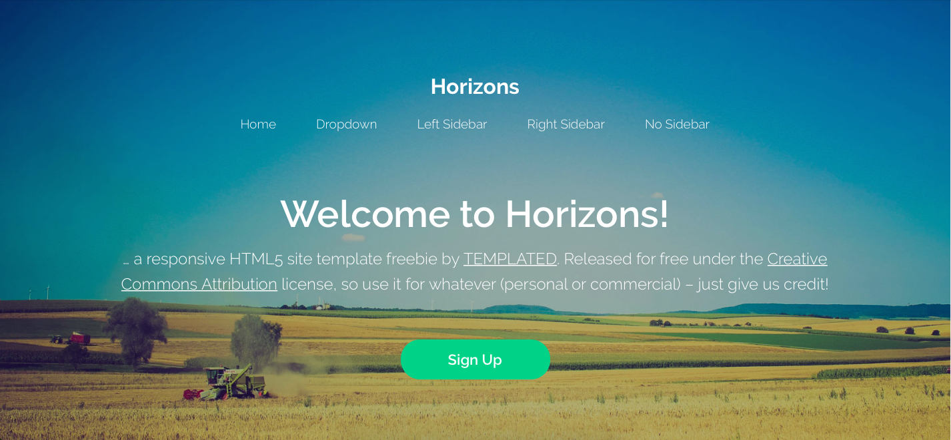

3-5 colors: screenshot from Adobe Color to show your planned color palette

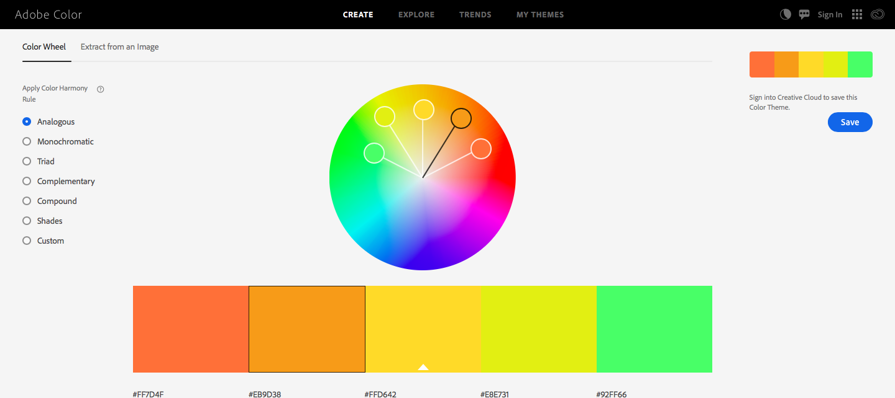

These would be good colors because it is shows the different colors of fall, summer, and spring.

8 pts. Wireframe & Mockup:

Use Balsamiq to create a simple sketch of the layout for your site to communicate the idea.

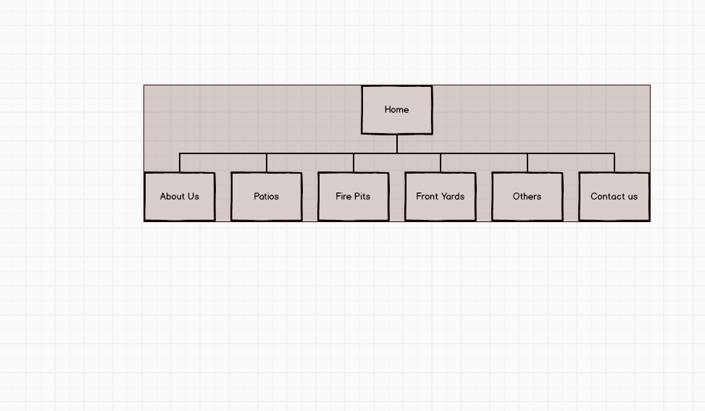

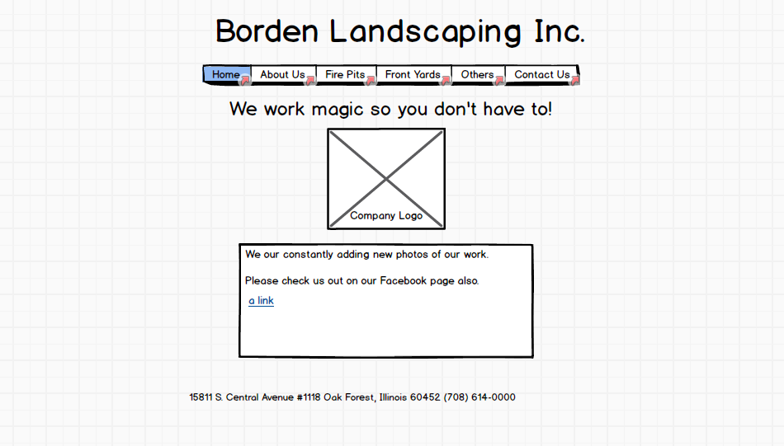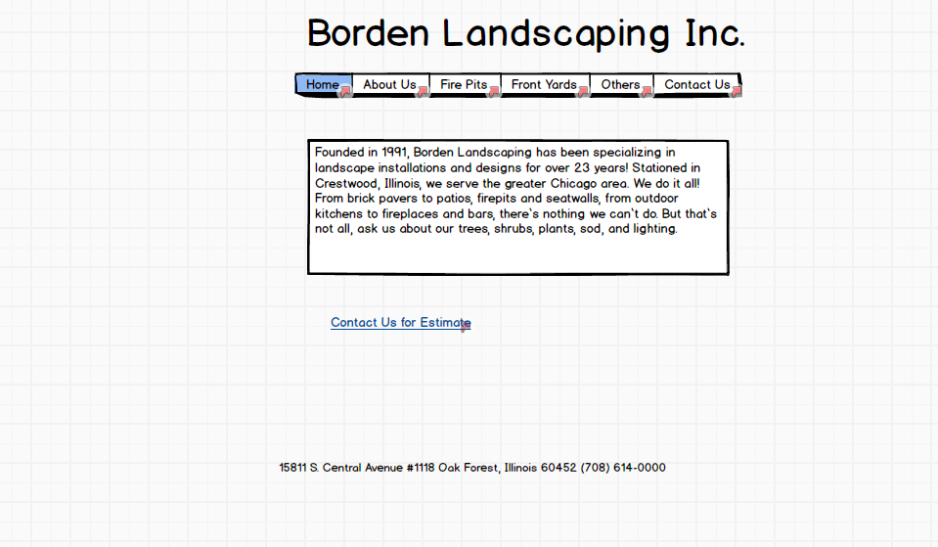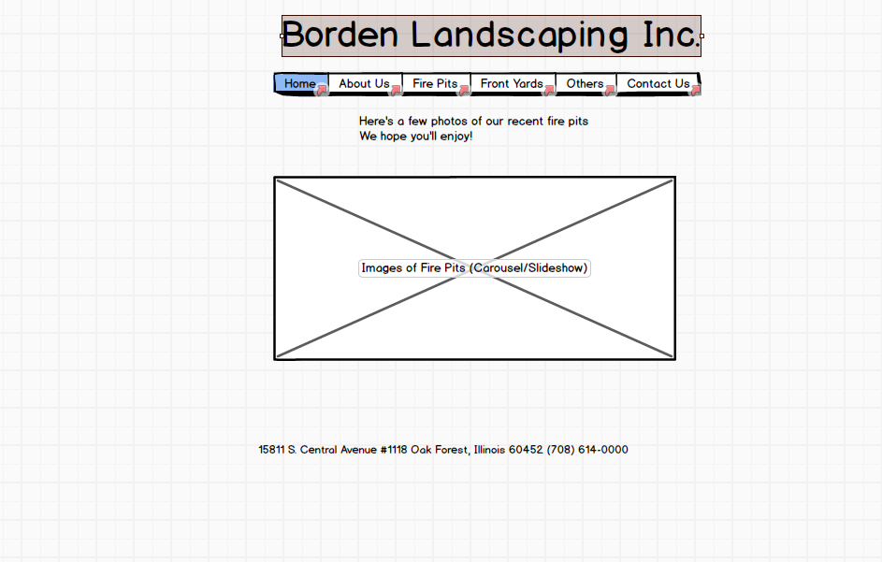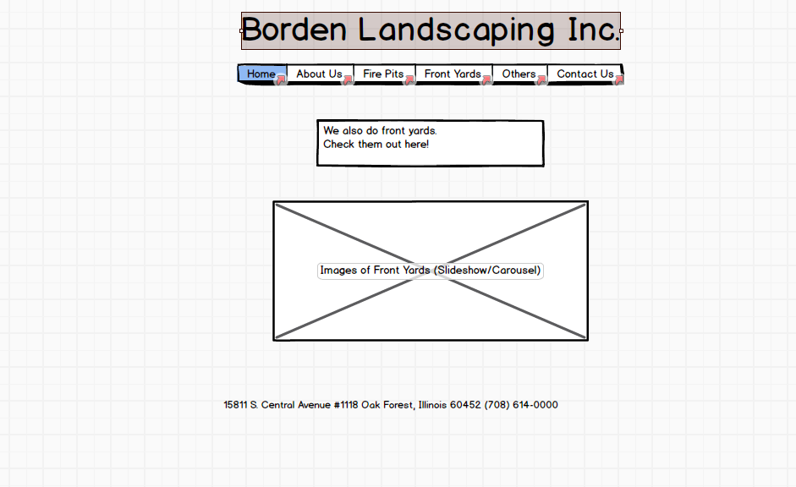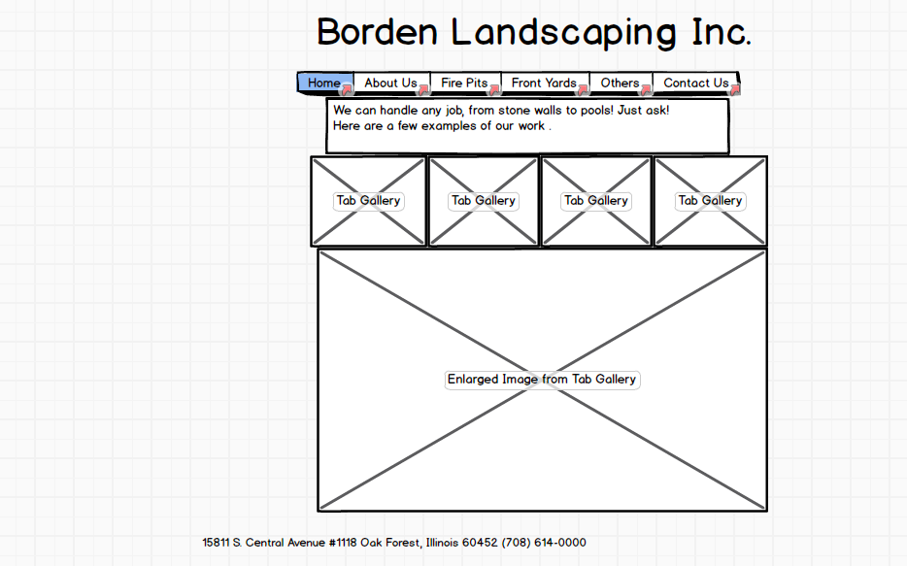

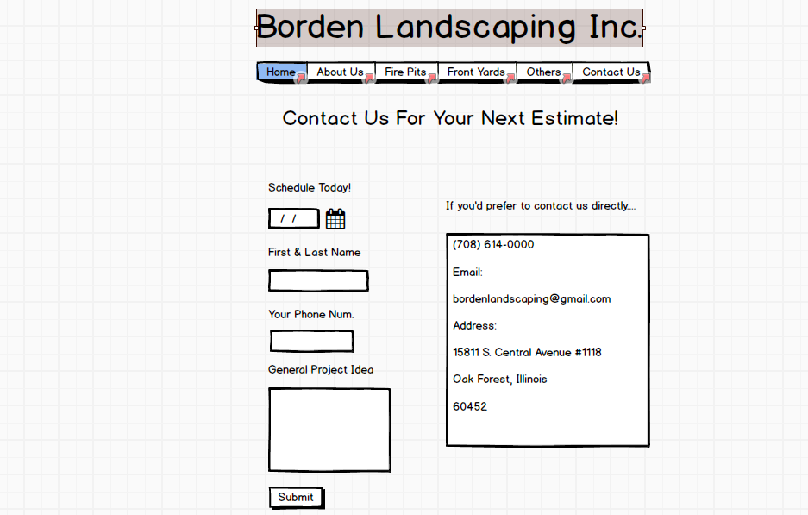

We might want to change our proposal, because we will be using some Javascript, so we don’t know which points would change because of that.

|  |  |  |
| --- | --- | --- |
| Elements | __/Points | Comments |
| HTML + CSS  **- 4 .html files - css is applied - includes home (index.html), design, and 2 additional pages** | **/30** |  |
| LAYOUT  **- Consistent nav on each page - Includes: header, body & footer** | **/10** |  |
| NAVIGATION  **- Easy and clear to use - Functional on all pages - Hover effect shows links** | **/10** |  |
| IMAGES  **- 2+ per page (except home page may have 1) - Images load quickly and have good resolution (saved at the right size and proportion)** | **/10** |  |
| CONTENT  **- No grammatical or spelling errors - Appropriate - Sufficient information *2 paragraphs per page is a good guide - some pages (like photo galleries) may need less text.*** | **/10** |  |
| DESIGN PRINCIPLES   * **Color Combination** * **Proximity** * **Repetition** * **Contrast** * **Alignment** * **Typography** | **/20** |  |
| CREATIVITY + PROBLEM SOLVING  **Went beyond the requirements to extend the learning experience** | **/10** |  |
| TOTAL | **100** |  |